

FIRST ASSIGMENT IN R 2023-2024

author
SERVOS DIMITRIOS, 1067563

Table Of Contents
1.First, use the summary function… 3
2.Determine the mean wage for your dataset. 7
3.Determine the mean age for your… 7
Obtain a kernel density for both variables… 8
1.Using the CPS1985 dataset and for categorical… 11
2.Consider the CPS1988 data, taken from Bierens and Ginther (2001) (try to find it in R). 16
3.Obtain scatterplots of the logarithm of the real wage (wage) versus experience and versus education. Please comment. 16
4.In fact, education corresponds to years of schooling and therefore takes on Υ a limited… 18
5.The data set contains four additional factors, ethnicity, smsa, region, and parttime. Obtain suitable graphical displays of log( wage) versus each of these factors. Comment. 19

ΩΡΑΙΑ

1.First, use the summary function…
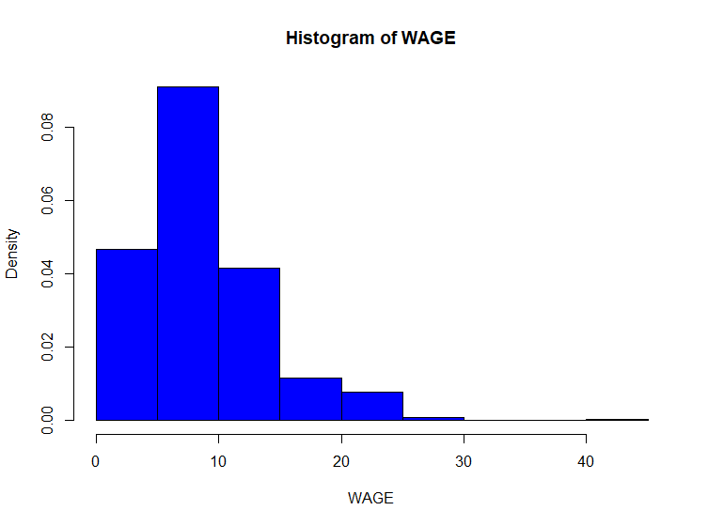
FIGURE 1. HISTOGRAM OF WAGE (in dollars per hour).

Comment(1): We observe that most of the sample is up to the value of 10 and slightly above. Furthermore, based on the chart, we notice possible outliers, and this hypothesis is supported by the difference between the mean (8.958) and the median (7.780).
ΠΡΟΣ ΤΑ ΔΕΞΙΑ-ΑΡΙΣΤΕΡΑ ΑΣΣΥΜΕΤΡΙΑ;;
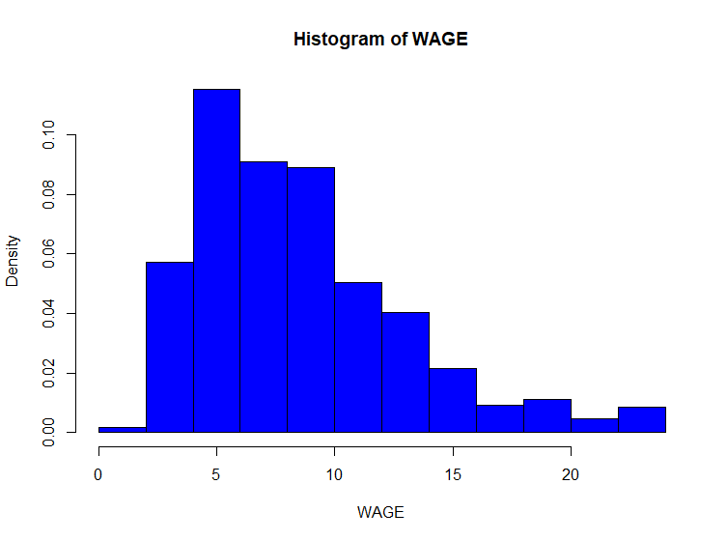
FIGURE 2. histogram of the WAGE variable , with outliers replaced by the mean value.

Comment(2): We considered any value that deviated by more than 3 standard deviations as an outlier and replaced it with the mean of the WAGE variable. As a result, we now have a distribution closer to normal, also allowing us to derive more consistent results for the WAGE variable, such as its mean.

FIGURE 3. Barplot of sector which represents the frequencies for each category

FIGURE 4. Pie chart of sector which represents the frequencies for each category.
Comment(3,4): Observing the bar plot and the pie chart for the variable SECTOR, we notice that the majority of the sample belongs to the category other.
FIGURE 5. Bar plot of occupation using frequencies for each category.
FIGURE 6. Pie chart for occupation using frequencies for each category.
Comment:(5,6): Based on the two charts, we observe that the categories with the lowest frequency are Sales and Management, where this often holds empirically. Finally, the category Other has the highest frequency.
ΔΕΝ ΘΑ ΤΑ ΕΒΑΖΑ ΜΕ ΣΧΟΛΙΑ-ΑΠΛΑ ΘΑ ΕΦΤΙΑΧΝΑ ΚΕΙΜΕΝΟ ΜΕ ΡΟΗ!!

2.Determine the mean wage for your dataset.
Mean (WAGE)= 9.024064.

3.Determine the mean age for your…
Mean (AGE)= 36.83333

FIGURE 7. Scatter plot of AGE against WAGE with a regression line.
Comment(7): Using Pearson Correlation (r=0.207) with a p-value < 0.01, it is statistically significant at a significance level of α=1, or in other words, a 1% chance of error. Thus, the strength of the linear relationship is weak (0.2-0.39). If age increases by one unit, the salary is expected to increase by approximately 0.2 units on average. ΔΕΝ ΕΧΕΙΣ ΕΚΤΙΜΗΣΗ ΑΠΛΑ ΜΙΑ ΣΧΕΣΗ!!

Obtain a kernel density for both variables…
FIGURE 8. The kernel density of NORTH using density.
FIGURE 9. The kernel density of log_NORTH using density.
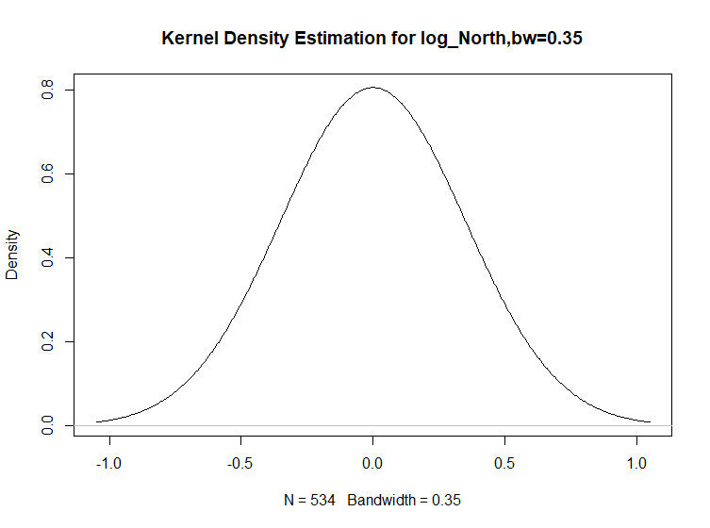
FIGURE 10. The kernel density of log_NORTH using density with arguments(bw).
Comment(8,9,10): We constructed the variable NORTH, where it takes a value of 1 if SOUTH equals 0 and vice versa. Using the kernel density, it shows us how our variable is distributed without necessarily adhering to any of the typical distributions. Observing the distribution of NORTH, it is necessary to use the logarithm so that the values come closer. As a result, we can better approximate the normal distribution, gaining useful properties for subsequent research and better visualization. Regarding the bandwidth (bw), the smaller it is, the more detailed the representation of the data. However, smaller bandwidth values make the density estimate more sensitive to variations in the data, potentially capturing smaller-scale fluctuations. Therefore, it is important to choose an appropriate bandwidth to achieve a smooth presentation of the data without losing crucial information.
ΤΙ ΜΑΣ ΔΕΙΧΝΟΥΝ ΤΑ Kernel??? Εχει σχεση με πιθανότητα;; ποσες κορυφες;; ποια η διαφορα από το ιστόγραμμα; Και γιατι το κάνουμε;;

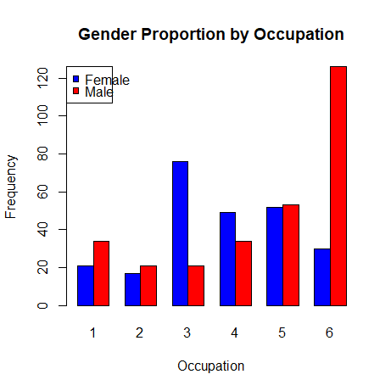
1.Using the CPS1985 dataset and for categorical…???

FIGURE 11. A barplot for gender proportion by occupation.
Comment(11): To start, we created a variable that takes the value 1 if you are male and 0 if you are female, which we named GENDER. We observe that three of the job categories seem to have a significant difference between the two genders. It's worth noting that the number 1 corresponds to the profession of a manager, where there are 34 males and 21 females. Another notable difference can be seen in category number 3(Clerical), where the majority are females with 76 women and 21 men. Moving on to further analysis, we expect to find some discrimination in the workplace based on an individual's gender.

FIGURE 12: Scatter plot of WAGE in relation to EDUCATION with a regression line.
Comment(12): To begin, it's worth mentioning that a Shapiro-Wilk normality test was conducted for the variable ln_WAGE. The result indicated that the p-value < 0.01, which means that we reject the null hypothesis that ln_WAGE follows a normal distribution. This is something we should take into consideration. Moving forward with our analysis, in order to generate consistent estimates, we need to be mindful of this deviation from normality in the ln_WAGE variable. Regarding the scatter plot between income and education, there appears to be a relationship, which we confirmed using Pearson's correlation test (r=0.36) with a p-value < 0.01. This means that income and education have a statistically significant weak positive linear correlation. Last but not least, there seems to be a differentiation in income based on the gender of the individual, with the mean income for men being 9.6 and for women being 7.6.
Ωραια!!

FIGURE 13: Boxplot for wage by gender.
FIGURE 14: Q-Q Plot for wage of males.
Τι μας δείχνει;;;;
FIGURE 15: Q-Q Plot for wage of females.
Comment(13,14,15): Observing the box plot of WAGE by GENDER, besides the difference in mean income that depends on GENDER, we also notice potential outliers, especially for the female GENDER, which could lead us to an inaccurate picture. In our example, the GENDER gap might be even larger than what is represented by a simple mean, and it would be advisable to consider the median as well. In the QQ-plots, apart from gaining information about how close the sample distribution is to a theoretical distribution, in our case, the normal distribution. Α ΩΡΑΙΑ!!! Moreover once again, we notice a more pronounced likelihood of having extreme values for females, and the line for females is lower than that for males, indicating that the values are centered around a smaller mean. Once more, we conclude that there is likely differentiation in wages based on gender.

ΤΙ ΓΡΑΜΜΕΣ ΕΙΝΑΙ ΑΥΤΕΣ;;
FIGURE 16: Boxplot of log(wage) by occupation.
Comment(16): Apart from observing an extreme value in category 1 (Management), we can also see that category 5 (Professional) has a high mean compared to the other professions. The gender ratio in this category is very close. Also, from the boxplot, it appears that the values are uniformly distributed for that specific occupation. We can conclude that maybe the differentiation in the average income does not originate from all professions.

2.Consider the CPS1988 data, taken from Bierens and Ginther (2001) (try to find it in R).
Commands in R.
library(AER)
data("CPS1988")

3.Obtain scatterplots of the logarithm of the real wage (wage) versus experience and versus education. Please comment.
FIGURE(17): Boxplot for WAGE.

FIGURE(18): Scatterplot of log(wage) versus experience.
FIGURE(19): Scatterplot of log(wage) versus education.
ΜΗΝ ΤΑ ΠΕΤΑΣ ΕΤΣΙ ΣΚΕΤΑ ΤΟ ΣΧΟΛΙΟ ΘΕΛΟΥΜΕ!!!
Comment(17,18,19): To begin with, we checked for outliers in the wage variable, meaning values deviating from the mean by more than 3 standard deviations. Since there were a considerable number of such values (389), we completely removed them from the sample instead of replacing them with a substitute such as the mean. This was done to ensure that the conclusions are represented as accurately as possible for the population. We observe that both for experience and education, there is a positive relationship with salary. However, we notice that the slope is more pronounced for education. We can say that education probably has a stronger linear relationship with salary compared to experience. Finally, it may be true that education is more influential in terms of salary than experience.

4.In fact, education corresponds to years of schooling and therefore takes on Υ a limited…
FIGURE(20): Parallel boxplots of wage stratified by levels of education.
Comment(20): Beyond the suspicion of extreme values, which depends on our flexibility and the nature of the research we want to conduct, we clearly observe that as education increases, the average income appears to rise. Furthermore, the years of education from 16 to 18 seem to be significantly impactful. There, the slope is quite pronounced, and depending on how we handle extreme values, it could be even more pronounced.

5.The data set contains four additional factors, ethnicity, smsa, region, and parttime. Obtain suitable graphical displays of log( wage) versus each of these factors. Comment.

FIGURE(21): Scatterplot of log(wage) by ethnicity.

FIGURE(22): Scatterplot of log(wage) by smsa.
FIGURE(23): Scatterplot of log(wage) versus region.

FIGURE(24): Scatterplot of log(wage) versus parttime.
Comment(21,22,23,24): Observing the four plots, the most pronounced linear relationship(strong negative relationship) with income appears to be with the part-time variable, indicating whether an individual works part-time or not. This aligns well with empirical evidence. Additionally, there seems to be almost no linear relationship with income for the variables Region and SMSA, where the SMSA variable takes the value one if the person resides in a Standard Metropolitan Statistical Area. Finally, based on ethnicity, it appears that being African American is associated with a relatively lower average income.

